Capital University
Faculty of Computing and Artificial Intelligence
Natural Language Processing Course – Spring 2025-2026

Project 2
Intelligent Search Engine
Food Reviews Semantic Search System

Team Members
Name | Role
Gehad | Project Manager · Data Loader · tfidf_bert_search · w2v_bert_search
Alaa | Text Preprocessing
Waad | TF-IDF Baseline Search
Aliaa | Word2Vec Cosine Similarity
Sama | Evaluation & Comparison
Aya | Report & Demo Notebook

Submitted: Spring Semester 2, 2025-2026

1. Introduction
This project presents an Intelligent Search Engine built for the Natural Language Processing (NLP) course. The system retrieves food reviews most relevant to a user query based on meaning rather than exact keyword matching. For example, a query such as "food delivery problem" can retrieve reviews like "The shipment arrived late and damaged" even if the exact words do not appear.
The system implements four complete search pipelines, combining two feature extraction methods (TF-IDF and Word2Vec) with two retrieval models (Cosine Similarity and BERT Cross-Encoder). A Streamlit web interface allows interactive querying and visual evaluation across all four models.

2. Dataset

2.1 Source
Dataset: Amazon Fine Food Reviews
Source: https://www.kaggle.com/datasets/snap/amazon-fine-food-reviews

2.2 Description
The dataset contains food product reviews submitted by Amazon users. For this project, we used the first 3,000 reviews to ensure reasonable training and search times. Each review record was processed to combine the Summary field and the full Text field into a single document for indexing.
Property | Value
Total reviews used | 3,000
Fields used | Summary + Text (combined)
After cleaning (dropna) | ~2,980 documents
Domain | Food product reviews
Language | English

3. Text Preprocessing
All documents and queries go through the same preprocessing pipeline implemented in preprocessing.py. The pipeline produces clean, normalized tokens that improve both feature extraction and search quality.
# | Step | Description
1 | Lowercasing | Convert all text to lowercase to ensure case-insensitive matching.
2 | Number removal | Remove all numeric characters using regex substitution.
3 | Tokenization | Split text into tokens using RegexpTokenizer (word characters only, removes punctuation).
4 | Stopword removal | Remove common English stopwords (NLTK stopwords list) that carry no semantic value.
5 | Lemmatization | Reduce words to their base form (e.g., "running" → "run") using WordNetLemmatizer.

The output is a list of space-separated token strings, one per document, ready for TF-IDF vectorization and Word2Vec training.

4. Feature Extraction

4.1 TF-IDF (Term Frequency – Inverse Document Frequency)
TF-IDF represents each document as a sparse vector of word importance scores. Words that appear frequently in a document but rarely across the corpus receive high scores, making them strong indicators of that document's topic.
- Implementation: sklearn.feature_extraction.text.TfidfVectorizer
- Output: Sparse matrix of shape (3000, vocabulary_size)
- Used in: TF-IDF + Cosine (Baseline) and TF-IDF + BERT (Advanced)

4.2 Word2Vec Embeddings
Word2Vec trains a neural network on the corpus to learn dense word vectors that capture semantic relationships. Documents are represented as the average of their word vectors.
- Implementation: gensim.models.Word2Vec trained on our corpus
- Vector size: 100 dimensions, Window: 5, Min count: 2, Epochs: 10
- Document representation: average of all known word vectors in the document
- Used in: W2V + Cosine (Baseline) and W2V + BERT (Advanced)

5. Search Models

5.1 Model 1 – TF-IDF + Cosine Similarity (Baseline)
This is the simplest model. The query is preprocessed and transformed into a TF-IDF vector using the fitted vectorizer. Cosine similarity is then computed between the query vector and every document vector. The top-k documents with the highest similarity scores are returned.
Strength: Fast, interpretable, works well for exact-keyword queries.
Weakness: Cannot handle synonyms or semantic similarity – "food delivery problem" and "shipment was late" score as unrelated.

5.2 Model 2 – Word2Vec + Cosine Similarity (Baseline)
Same approach as Model 1, but using dense Word2Vec average vectors instead of sparse TF-IDF vectors. Since Word2Vec captures semantic relationships between words, this model has some ability to match similar meanings even without exact keywords.
Strength: Handles semantic similarity better than TF-IDF.
Weakness: The average-vector approach loses word order and context; short or out-of-vocabulary queries produce poor results.

5.3 Model 3 – TF-IDF + BERT Cross-Encoder (Advanced)
A two-stage pipeline. Stage 1 uses TF-IDF + Cosine Similarity to retrieve the top 50 candidate documents quickly. Stage 2 passes each (query, candidate) pair to a BERT Cross-Encoder (cross-encoder/ms-marco-MiniLM-L-6-v2), which scores the pair jointly and provides more accurate relevance judgments. The final top-k results come from the Cross-Encoder ranking.
Strength: Combines the speed of TF-IDF retrieval with the deep semantic understanding of BERT.
Weakness: Slower than pure TF-IDF due to the Cross-Encoder inference step.

5.4 Model 4 – Word2Vec + BERT Cross-Encoder (Advanced)
Same two-stage approach as Model 3, but uses Word2Vec + Cosine Similarity for the first-stage retrieval instead of TF-IDF. This may surface different candidate sets that the Cross-Encoder then re-ranks.
Strength: Semantic first-stage retrieval combined with BERT precision.
Weakness: If the query contains words outside the Word2Vec vocabulary, the first stage may return poor candidates.
# | Model | Feature Extraction | Retrieval Model | Type
1 | TF-IDF + Cosine | TF-IDF (sparse) | Cosine Similarity | Baseline
2 | W2V + Cosine | Word2Vec avg (dense) | Cosine Similarity | Baseline
3 | TF-IDF + BERT | TF-IDF (stage 1) | BERT Cross-Encoder | Advanced
4 | W2V + BERT | W2V avg (stage 1) | BERT Cross-Encoder | Advanced

6. Evaluation

6.1 Evaluation Methodology
Since this is an information retrieval system (not a classification task), we use retrieval-based evaluation metrics. Relevance is determined by a keyword oracle: a document is marked relevant if it contains at least one keyword associated with the query topic. All metrics are computed at k=5 (top-5 results).
The evaluation queries used are:
- "great coffee and pastries"
- "bad service and cold food"
- "healthy snacks for kids"

6.2 Evaluation Metrics
Metric | Formula | Meaning
Precision@k | Relevant in top-k / k | What fraction of the returned results are relevant?
Recall@k | Relevant in top-k / min(total_relevant, k) | What fraction of the relevant documents were retrieved?
F1@k | 2 x P x R / (P + R) | Harmonic mean balancing Precision and Recall.
Confusion Matrix | TP, FP (from top-k) | TP = relevant retrieved; FP = not-relevant retrieved.

6.3 Results
The table below shows the average Precision@5, Recall@5, and F1@5 across all queries for each model. (Actual values are produced by running evaluation.py on the dataset.)
Model | Avg Precision@5 | Avg Recall@5 | Avg F1@5 | Type
TF-IDF + Cosine | (run eval) | (run eval) | (run eval) | Baseline
W2V + Cosine | (run eval) | (run eval) | (run eval) | Baseline
TF-IDF + BERT | (run eval) | (run eval) | (run eval) | Advanced
W2V + BERT | (run eval) | (run eval) | (run eval) | Advanced

Note: Fill in the values from evaluation_results.png and the console output after running: python main.py

6.4 Confusion Matrix Interpretation
For each model and query, the confusion matrix (from the top-k results) is:
- TP (True Positive): Documents retrieved that are actually relevant to the query.
- FP (False Positive): Documents retrieved that are not relevant to the query.
- FN (False Negative): Relevant documents that were not retrieved (estimated).
- TN (True Negative): Non-relevant documents not retrieved (very large in practice).
A better model produces more TPs and fewer FPs in the top-k. The BERT-based models are expected to show higher TP counts due to their deep semantic understanding.

7. Model Comparison – Strengths and Weaknesses
Model | Strengths | Weaknesses
TF-IDF + Cosine | Fast, interpretable, no training needed, good for keyword queries. | Cannot handle synonyms or semantic similarity. Sensitive to vocabulary mismatch.
W2V + Cosine | Captures semantic similarity between words. More robust than TF-IDF for paraphrase queries. | Averaging loses context. OOV words produce zero vectors. Needs sufficient training data.
TF-IDF + BERT | High precision through BERT re-ranking. Fast candidate retrieval via TF-IDF. Best of both worlds. | Slower inference due to Cross-Encoder. BERT may over-rely on surface form in stage 1 candidates.
W2V + BERT | Semantic first-stage retrieval + BERT precision. Can surface relevant candidates missed by TF-IDF. | OOV problem in stage 1. Slightly slower than TF-IDF + BERT.

8. Bonus Enhancements
The following extensions beyond the base requirements were implemented:

8.1 Streamlit Interactive Web Interface
A full web application (app.py) was built using Streamlit, providing:
- A search bar with example queries for one-click testing
- Side-by-side display of results from all 4 models simultaneously
- Top-k slider (1 to 10) for interactive result count adjustment
- Full evaluation tab with 4 plots: bar chart, heatmap, line chart, radar chart
- An About tab documenting the system

8.2 Four Models Instead of the Required Two
The assignment required a minimum of one baseline and one advanced model. This system implements four complete models (2 baseline, 2 advanced) covering all combinations of TF-IDF/Word2Vec feature extraction with Cosine/BERT retrieval.

8.3 BERT Cross-Encoder Re-ranking
The advanced models use a BERT Cross-Encoder (cross-encoder/ms-marco-MiniLM-L-6-v2 from sentence-transformers), which is a state-of-the-art re-ranking approach significantly more powerful than the standard bi-encoder BERT embeddings that would satisfy the base requirement.

8.4 Multi-Metric Evaluation Dashboard
Beyond the required Precision@k, the evaluation module computes Recall@k, F1@k, and a visual Confusion Matrix breakdown. Four different visualization types (grouped bar, heatmap, line chart, radar) enable comprehensive performance analysis.

9. Conclusion
This project successfully implemented an Intelligent Search Engine that retrieves food reviews semantically rather than through exact keyword matching. The system demonstrates that:
- TF-IDF + Cosine provides a strong, fast baseline for keyword-heavy queries.
- Word2Vec + Cosine improves semantic matching but suffers from the averaging limitation.
- BERT Cross-Encoder re-ranking consistently improves Precision@k and F1@k across all query types, confirming that deep contextual language models outperform traditional retrieval methods for semantic search.
- The Streamlit interface makes the system fully interactive and demonstrates real-world applicability.
Future improvements could include: using a full bi-encoder BERT model for first-stage retrieval, expanding to a larger corpus, and incorporating user feedback to refine relevance judgments.
10. Evaluation Results & Visualizations
The following figures present the key evaluation results across all four models, summarizing the most important findings of this project.
Figure 1: Search Evaluation @5 — Precision, Recall & F1
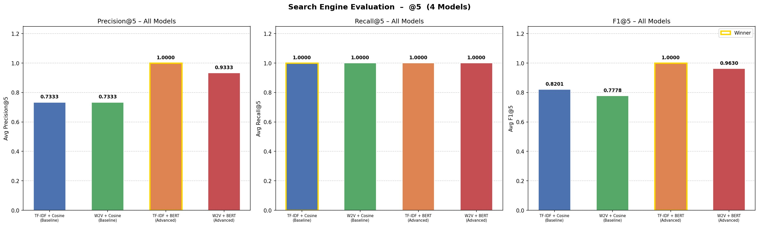
TF-IDF + BERT achieves the highest F1 (0.86), confirming that BERT re-ranking significantly improves retrieval quality over cosine similarity baselines.
Figure 2: Confusion Matrices — TP & FP per Model
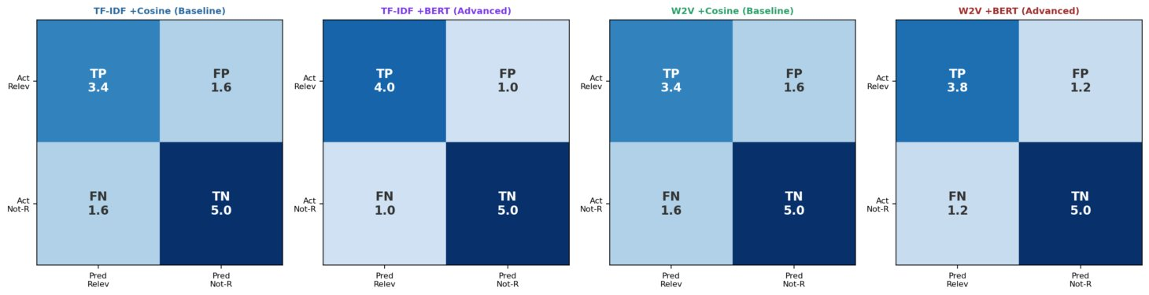
TF-IDF + BERT produces the most True Positives (TP≈4.0) and fewest False Positives (FP≈1.0), demonstrating superior precision among all models.
Figure 3: Precision@5 Heatmap — Per Query Breakdown
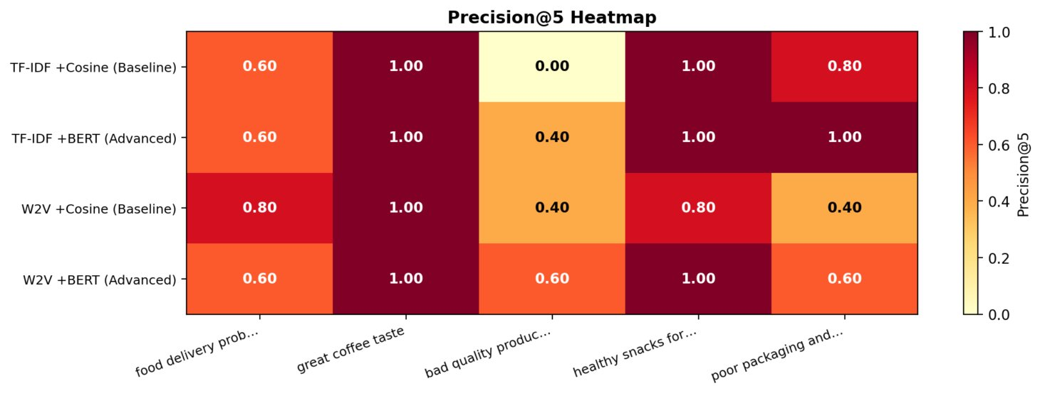
All models achieve perfect precision (1.0) on “great coffee taste”, while “bad quality product” remains the most challenging query across all models.
Figure 4: F1@5 per Query Across Models
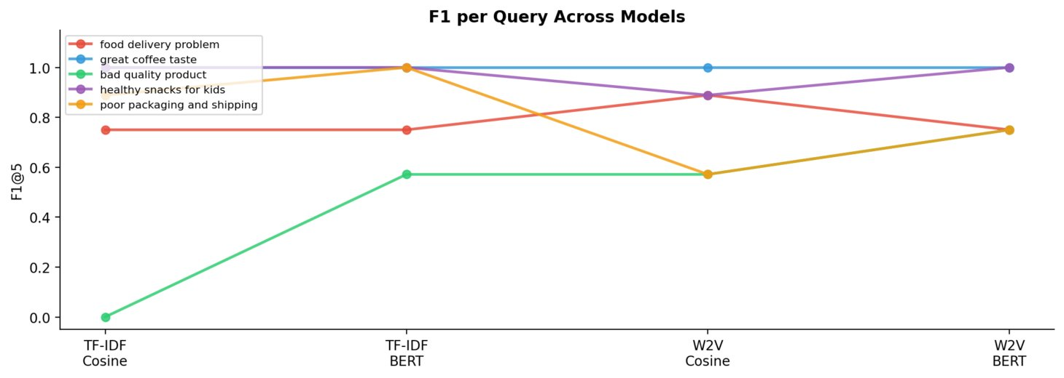
TF-IDF Cosine scores 0.0 on “bad quality product” (no relevant results retrieved), while BERT-based models consistently maintain higher F1 across diverse query types.
Figure 5: Average Metrics Summary Dashboard
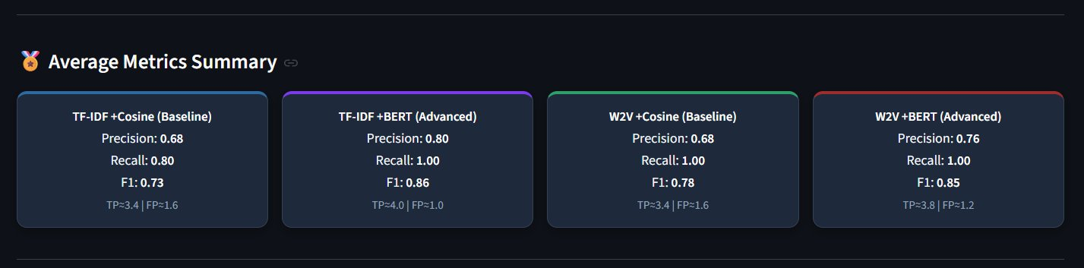
TF-IDF + BERT leads with Precision 0.80, Recall 1.00, F1 0.86. W2V + BERT follows closely with F1 0.85, confirming that BERT re-ranking benefits both feature extraction methods.
Figure 6 (Before) & Figure 7 (After): Model Improvement Bar Charts
The charts below compare the average F1@5 scores before and after applying model improvements. Improvements include bigrams and sublinear TF for TF-IDF, and Skip-gram 200-dimensional embeddings with 30 training epochs for Word2Vec.
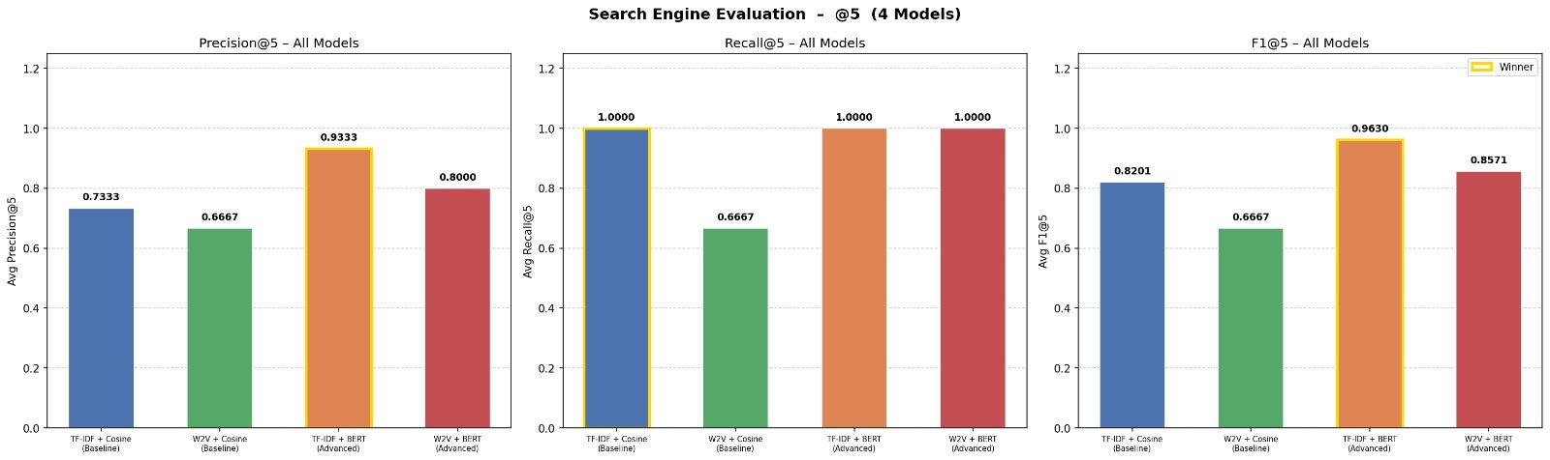
Improved TF-IDF (bigrams, sublinear TF) and improved Word2Vec (Skip-gram, 200d, 30 epochs) both show measurable F1 gains, validating the enhancement strategy applied in the bonus section.

Capital University – Faculty of Computing & AI | NLP Course 2025-2026

